DS PRACTICAL NO. :- 02

**AIM :- [A] : Create an array of size n and write a program to insert an element (beginning, end and specific position).**

**Beginning program :**

//insertion at first position

#include<iostream>

using namespace std;

int main(){

    int a[100];

    int size;

    cout<<"enter the size of array"<<endl;

    cin>>size;

    int no;

    cout<<"enter no that u want to add initially"<<endl;

    cin>>no;

    cout<<"enter array"<<endl;

    for(int i=0;i<size;++i){

        cin>>a[i];

    }

    for(int i=size;i>0;--i){

        a[i]=a[i-1];

    }

    a[0]=no;

    cout<<"updated array is"<<endl;

    for(int i=0;i<=size;++i){

        cout<<a[i]<<" ";

    }

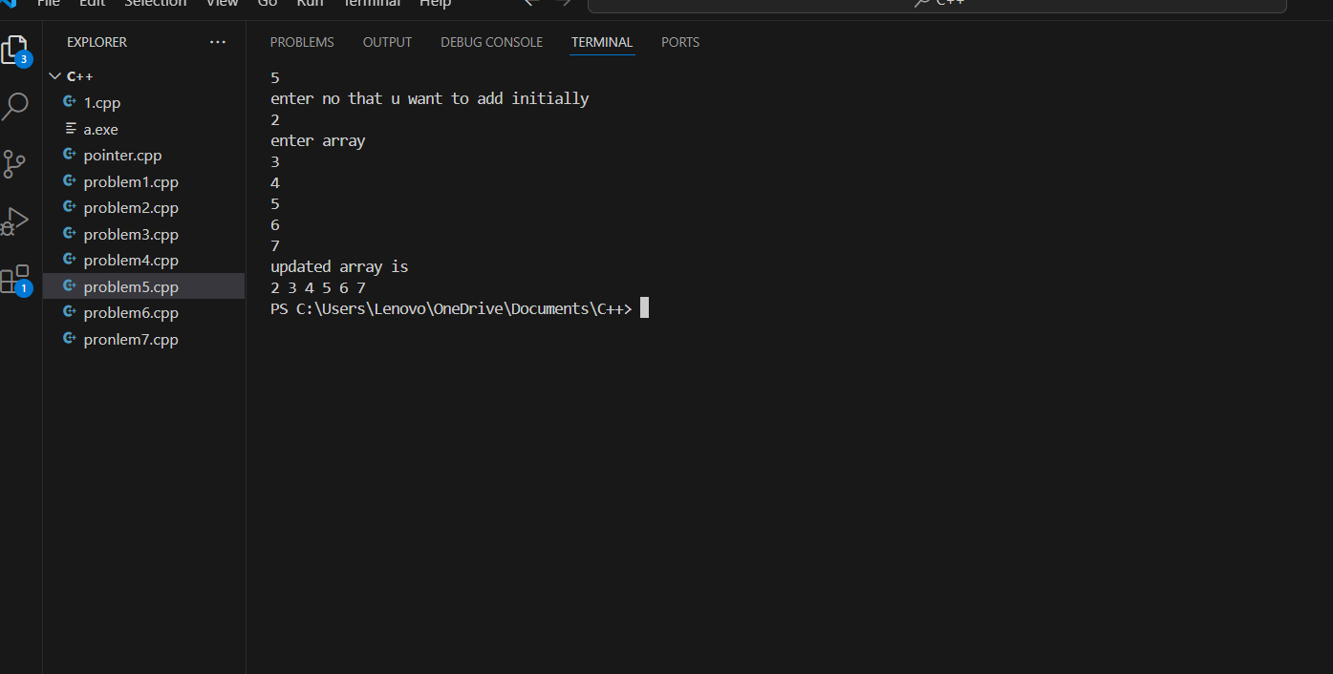

**At any position :**

#include<iostream>

using namespace std;

int main(){

int a[100], n,b ;

int position;

cout<<"entere the array size" ;

cin>>n;

for(int i=0;i<n;i++){

    cout<<a[i];

}

for(int i=0;i<n;i++){

    cin>>a[i];

}

cout<<"Entere the number which to be inserted:";

cin>>b;

cout<<"entere the position:";

cin>>position;

if(position<0||position>n){

    cout<<"invalind position";

    return 1;

}

for(int i=n;i>position;i--){

    a[i]==a[i-1];

}

a[position]=b;

n++;

cout<<"new array";

for(int i=0; i<n; i++){

    cout<<a[i]<<" ";

}

cout<<endl;

return 0;

}

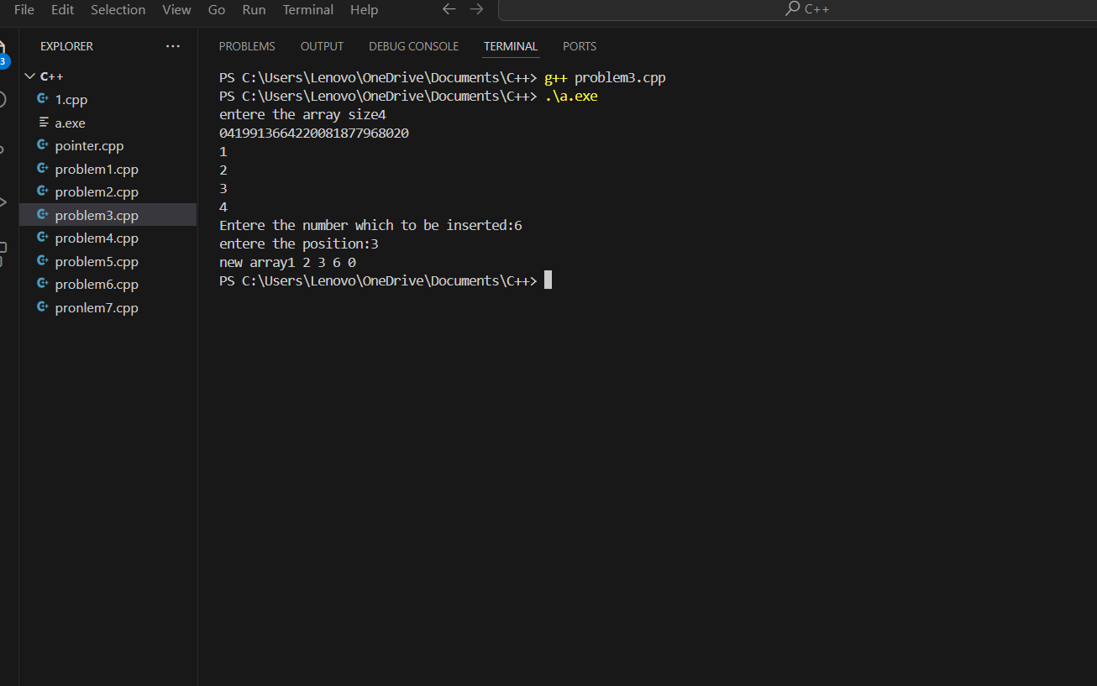

**At end position:**

#include<iostream>

using namespace std;

int main(){

    int array[50];

    int size;

    int element;

    cout<<"element that you want to add in last"<<endl;

    cin>>element;

    cout<<"enter the size of array"<<endl;

    cin>>size;

    cout<<"enter array"<<endl;

    for(int i=0;i<size;i++){

        cin>>array[i];

    }

    array[size]=element;

    cout<<"enter updated array"<<endl;

    for(int i=0;i<=size;i++){

        cout<<array[i]<<" ";

    }

}

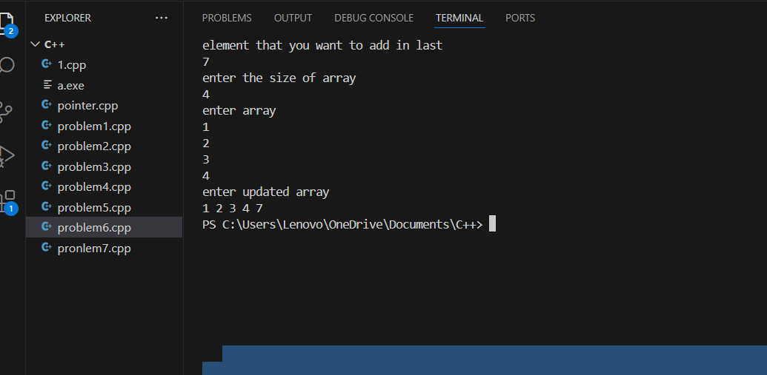

**[B]:- Create an array of size n and write a program to delete an element (begining, end and specific position).**

**At Beginning :**

    #include<iostream>

    using namespace std;

    int main(int argc, char const *argv[])

    {

        int a[100]={10,20,30,40,50};

        int size=5;

        for(int i=0; i<size-1;i++){

            a[i]=a[i+1];

        }

        size--;

        cout<<"new array";

        for(int i=0; i<size;i++){

            cout<<a[i]<<" ";

        }

        return 0;

    }

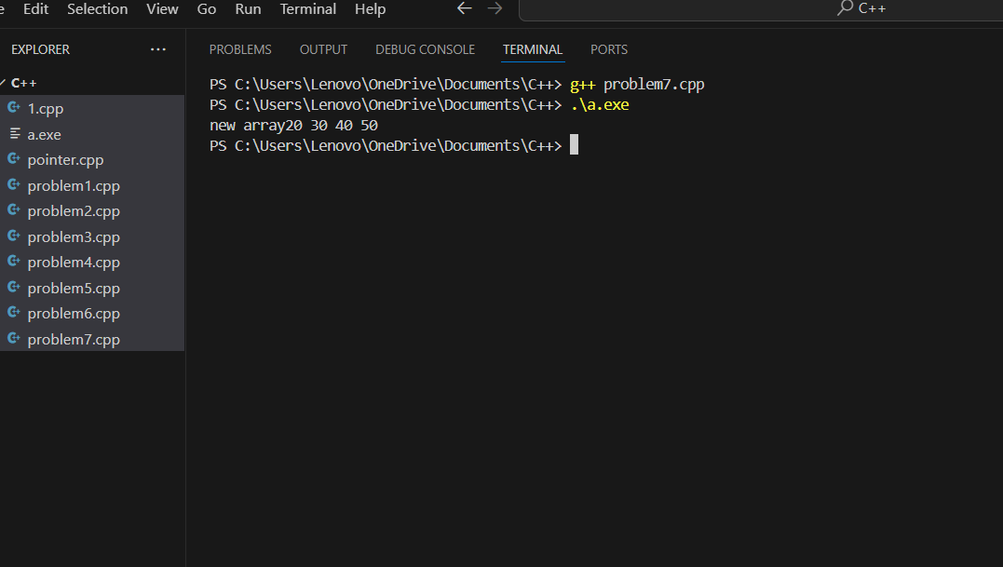

**At any position :**

#include<iostream>

using namespace std;

int main(){

int a[100], n;

int position;

cout<<"entere the array size" ;

cin>>n;

for(int i=0;i<n;i++){

    cout<<a[i];

}

for(int i=0;i<n;i++){

    cin>>a[i];

}

cout<<"entere the position:";

cin>>position;

if(position<0||position>n){

    cout<<"invalind position";

    return 1;

}

for(int i=position;i<n-1;i++){

    a[i]==a[i+1];

}

n--;

cout<<"new array";

for(int i=0; i<n; i++){

    cout<<a[i]<<" ";

}

cout<<endl;

return 0;

}

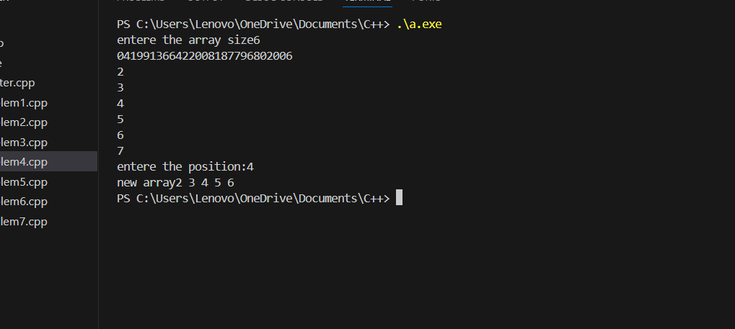

**At end position :**

#include<iostream>

    using namespace std;

    int main(int argc, char const *argv[])

    {

        int a[100]={10,20,30,40,50};

        int size=5;

        size--;

        cout<<"new array";

        for(int i=0; i<size;i++){

            cout<<a[i]<<" ";

        }

        return 0;

    }

